Biodiversity Collage Project (50 points) | Name:
 | Date/Per:

Project Purpose: To identify the significance of biodiversity on Earth, and name the six kingdoms of life.

Biodiversity refers to the number of different species in a given area. A “species” is a group of similar organisms that can mate with each other and produce fertile offspring. Biodiversity is a good thing! Food, medicine, shelter, clothing, engineering and many other benefits come from biodiversity.

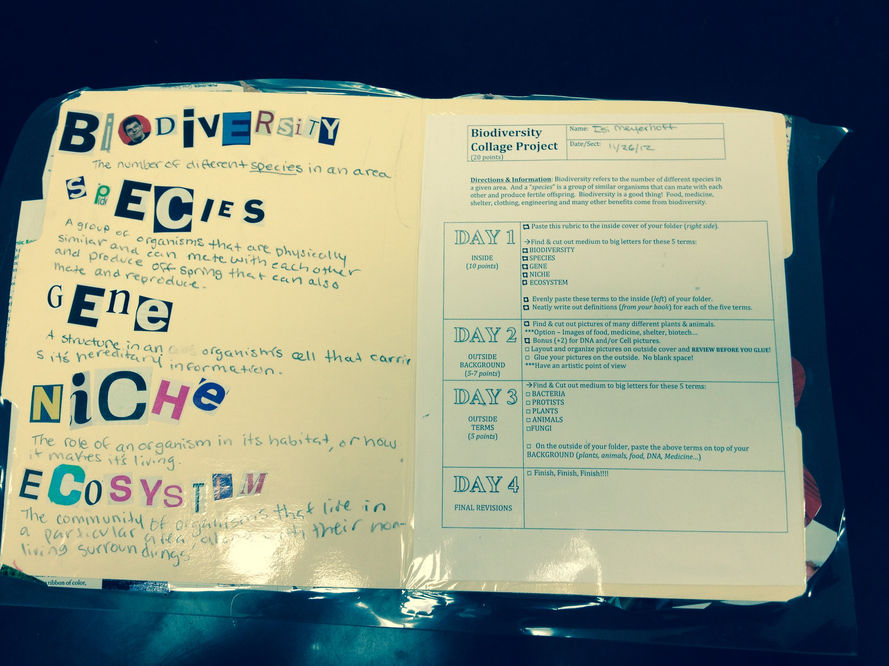  INSIDE  DAY 1  (15 points) | ☐ Paste this rubric to the inside cover of your folder (right side).  Find & cut out medium to big letters for these 5 terms:  ☐BIODIVERSITY  ☐SPECIES  ☐GENE  ☐NICHE  ☐ECOSYSTEM  ☐ Evenly paste these terms to the inside (left) of your folder.  ☐ Neatly write out definitions (from your book) for each of the five terms.
DAY 2  OUTSIDE BACKGROUND  (10 points) | ☐ Find & cut out pictures of many different plants & animals.  ***Option – Images of food, medicine, shelter, biotech…  ☐ Layout and organize pictures on outside cover and  REVIEW BEFORE YOU GLUE!  ☐ Glue your pictures on the outside. No blank space!  ***Have an artistic point of view  ☐ Start Group Poetry Jam! – Teacher provided template.
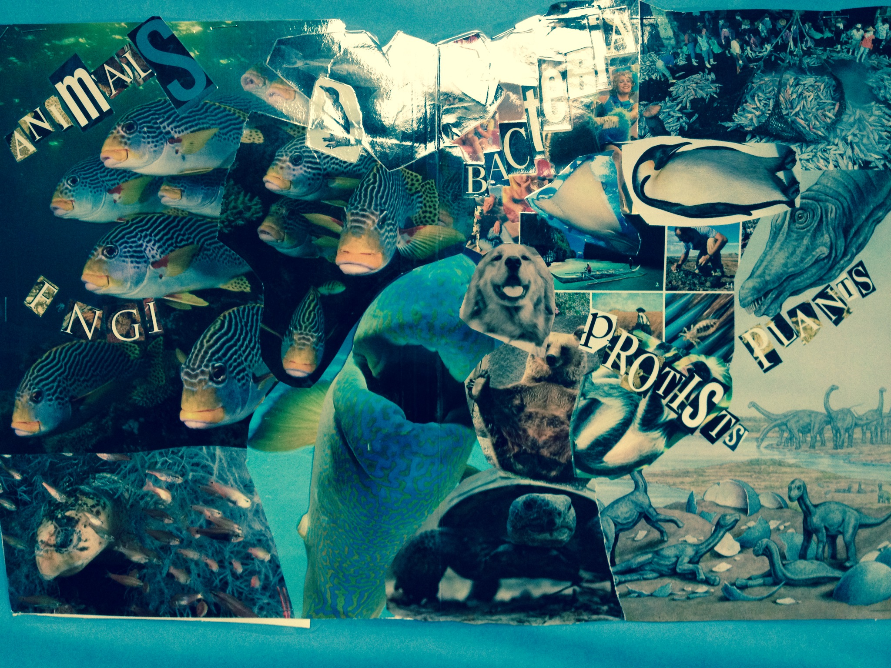  DAY 3  Six Kingdoms (15 Points) – On Outside | Find & Cut out medium to big letters for the 6 Kingdoms:  ☐ ARCHAE  ☐ BACTERIA  ☐ PROTISTS  ☐ PLANTS  ☐ FUNGI  ☐ ANIMALS  ☐ On the outside of your folder, paste the kingdom names on top of your BACKGROUND.  ☐ Finish Poetry Jam & Rehearse
(10 points)  DAYS 4 & 5  FINAL REVISIONS | ☐ Biodiversity Poetry Jam (10 points) Rehearse & Perform.  - Bonus points if memorized (+3)  ☐ Finish, Finish, Finish!!!!

Why is biodiversity important?

